**Unit Test report**

**Project**: TechNologyOne_Interview **Date**: 24/08/23/ 03:02 PM  
**Tester**: Wonwoo Choi

* Total Number of Tests:15
* Passed Tests: 14
* Failed Tests: 1
* Skipped Tests: 0
* Duration: 0.0412829 seconds

**Summary**

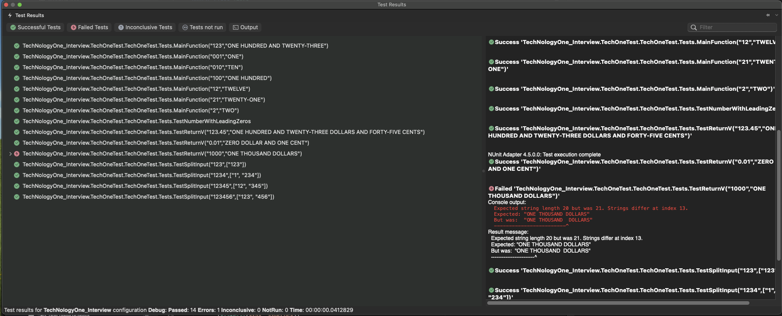

First Test

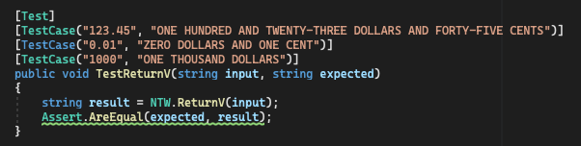

- Status: Failed

- Error:

1. Expected string length 20 but was 21. Strings differ at index 13.

Expected: "ONE THOUSAND DOLLARS"

But was: "ONE THOUSAND DOLLARS"

- Memo: Try to figure it out why there is double space between Thousand but couldn’t figure it out and try to fix it.

Second Test

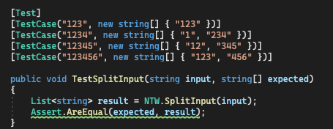

Status: Passed

Third Test

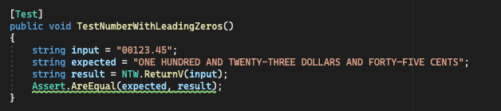

Status: Passed

Fourth Test



Status: Passed

Action:  
I will fix the code on NTW.ReturnV funcJon and figure it out why the test failed and fix it.